PARIS PEIKWEN CHENG
SOLO SHOW LOST AND FOUND
MAY 17th – JUNE 7th 2014
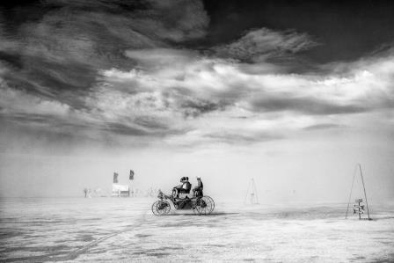

Peikwen Cheng, Searching for lost horizons

To promote and maintain emerging artists is Magda Danysz gallery main goal since its creation. Magda Danysz still follow this commitment and her new talents quest. By the way, from May 17th to June 7th 2014 she presents the first solo show of Chinese photographer Peikwen Cheng.

Peikwen Cheng is a young chinese photographer, a photographer "free as a bird" to quote the journalist Nicolas Jucha. His works from "Lost and founds" set draw inspiration in the Burning Man festival in the Nevada Black Rocks desert, hostile and inospitable landscape in which every year fanciful people are getting together and are giving their dreams realisation and most strange whims free rein. Peikwen Cheng relates in his set photographies, realised between 2000 and 2013, this excessiveness, those antics and shows an unreal universe full of plastic sunflowers, of huge rocking horse and of rockets which seem to straight out of a tale.

In his surprising visions, like child dreams, Peikwen Chang captures the exact moment when the dream seems to join the reality. His matt printings by inkjet on fine art paper increase more his intention evanescence. He takes us back by his side in this distraught and powerful vision which are the Burning Man festival own caracteristics. Peikwen Cheng finds the perfect balance between documentary photographies and the staging and meticulous pictures in which he knows so well to capture the exact moment when the light as much as the landscape have their real significiance. So we discover an enchanted world, a gripping beauty, in this incredibly inospitable place in the grif of dust gales.

This exhibition to the Magda Danysz gallery introduces us directly to the Chinese contemporary photography through one of its original actor shots.

PEIKWEN CHENG – SOLO SHOW: Exhibition from May 17th to June 7th 2014
Openning: Saturday May 17th 2014 from 18pm to 21pm
Place : Galerie Magda Danysz, 78 rue Amelot, Paris 11
Phone : +33 (0)1 45 83 38 51 Website : www.magda-gallery.com
Press Contact : Clémence Wolff +33 (0)1 43 57 79 78 clemence@mnacommunication.com

